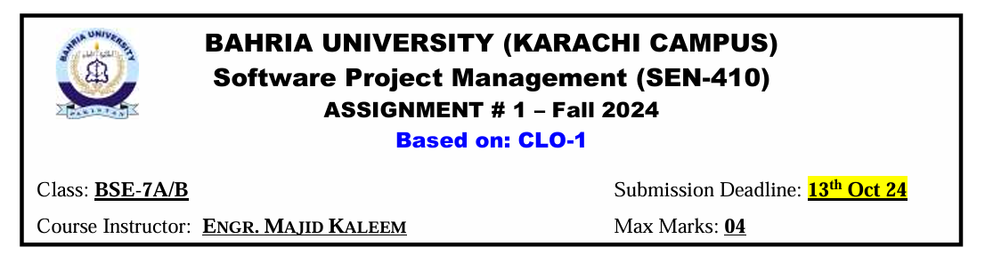

**Question 1:** **Describe the significance of the Project Integration Management knowledge area in software project management. What are the key processes and activities involved in integrating various project components, and how does it help ensure project success?**

**Answer:**

Project Integration Management is crucial in software project management as it ensures all project components are effectively coordinated to meet overall project goals. It involves integrating various project aspects like scope, resources, timelines, and deliverables.

**Significance of Project Integration Management**

Project Integration Management is essential for several reasons:

* Holistic Approach: It provides a comprehensive view of the project, considering all aspects and their interdependencies.
* Coordination: It coordinates all project elements, including tasks, resources, stakeholders, and deliverables.
* Efficiency: It ensures that processes run efficiently and meet predefined goals.
* Conflict Resolution: It helps manage conflicts between different aspects of a project and make necessary trade-offs.
* Stakeholder Satisfaction: It enables project managers to make informed decisions that meet stakeholder expectations.

**Key Processes and Activities**

Project Integration Management includes several essential processes and activities:

* **Develop Project Charter**: Establishing a document that defines the project's purpose, scope, and key stakeholders.
* **Develop Project Management Plan**: Formulating a detailed plan to guide project execution.
* **Direct and Manage Project Work**: Carrying out project tasks and activities according to the plan.
* **Monitor and Control Project Work**: Monitoring project progress and addressing any deviations from the plan.
* **Perform Integrated Change Control**: Handling changes to the project's scope, schedule, or budget.
* **Close Project or Phase**: Finalizing the project or a phase and formally closing it.
* **Manage Project Knowledge**: Gathering, documenting, and sharing information related to the project.

**How It Helps Ensure Project Success:**

Project Integration Management plays a key role in ensuring project success through several benefits:

1. **Enhanced Communication**: It fosters better communication among team members and stakeholders by integrating all project aspects.
2. **Optimized Resource Allocation**: It ensures resources are effectively allocated based on the overall project requirements.
3. **Risk Reduction**: By evaluating interdependencies, it helps identify and address risks early on.
4. **Adaptability**: It provides the flexibility to make adjustments and trade-offs to keep the project on course.
5. **Strategic Alignment**: It ensures the project aligns with the organization’s broader strategic goals.
6. **Improved Decision-Making**: By offering a comprehensive project view, it enables more informed decisions throughout the project lifecycle.

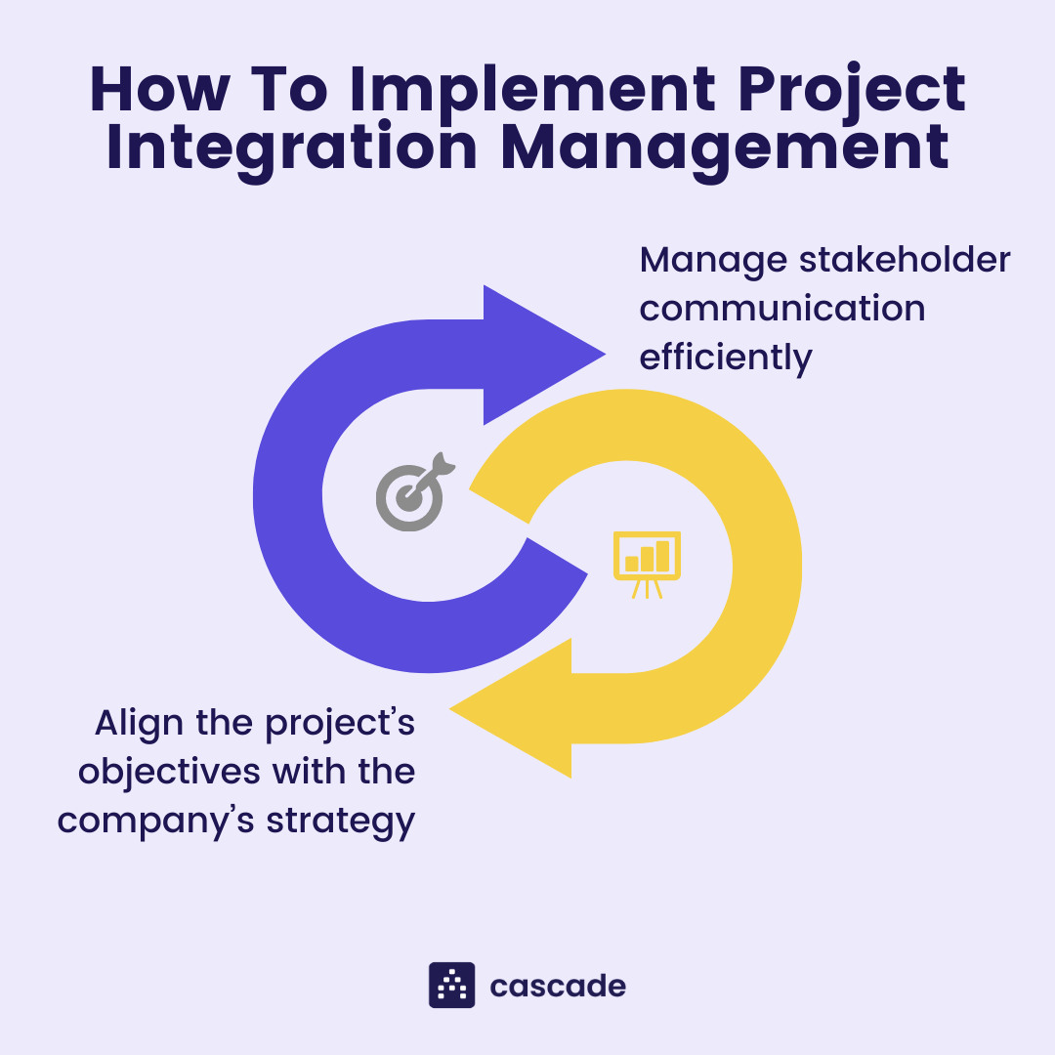

In summary, Project Integration Management is essential for the success of software projects as it offers a structured approach to coordinating all project elements, resolving issues, and ensuring alignment with organizational objectives. Its processes enable project managers to handle complexities, make well-informed decisions, and deliver outcomes that meet stakeholder expectations.

**Question 2: Explore the Project Scope Management knowledge area within PMI's framework. Describe how effective scope management impacts software project outcomes, and what are the primary processes involved in this knowledge area?**

**Answer:**

Project Scope Management is one of the ten knowledge areas in the Project Management Institute's (PMI) framework. It deals with defining and controlling what is included in a project and what is not. Effective scope management is crucial for software project success, as it helps prevent scope creep, ensures alignment with stakeholder expectations, and maintains project focus.

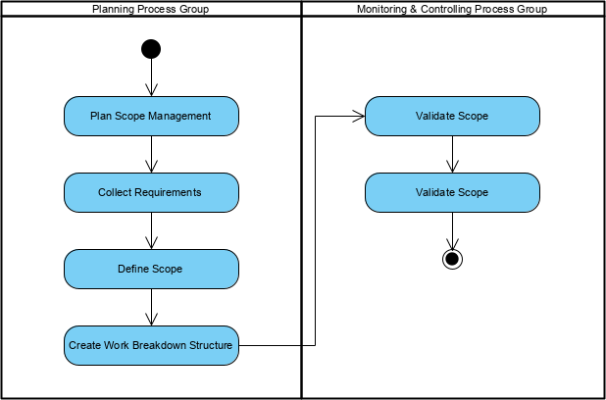

**Impact on Software Project Outcomes**

* **Prevents Scope Creep**: Clearly defines project boundaries, avoiding unnecessary additions.
* **Improves Stakeholder Satisfaction**: Ensures all stakeholders understand project deliverables.
* **Enhances Resource Allocation**: Efficient resource use through a well-defined scope.
* **Reduces Risk**: Identifies risks early, enabling better mitigation.
* **Supports Agile Methodologies**: Offers flexibility while keeping the project on track

**Primary Processes Involved**

The Project Scope Management knowledge area includes six primary processes:

* **Plan Scope Management**: Develop a plan outlining how the scope will be defined, validated, and controlled.
* **Collect Requirements**: Gather and document stakeholder needs through various techniques.
* **Define Scope**: Prepare a detailed scope statement with clear deliverables.
* **Create Work Breakdown Structure (WBS)**: Break the scope into smaller, manageable tasks.
* **Validate Scope**: Obtain formal acceptance of deliverables.
* 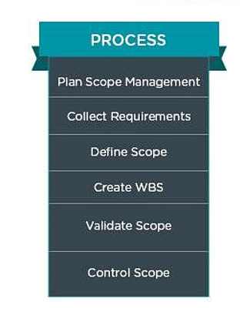**Control Scope**: Monitor and manage changes to the project scope.

**1. Plan Scope Management**

The first process involves creating the Scope Management plan, which details how the project scope will be defined, validated, and managed throughout its lifecycle. It includes key aspects such as:

* Defining the method for gathering requirements
* Setting up procedures for validating and controlling the scope
* Outlining how scope changes will be managed

**2. Collect Requirements**

In this process, the project team collects and records stakeholder needs and expectations. This can be done using techniques like interviews, surveys, and workshops.

**3. Define Scope**

In this process, a comprehensive description of the project and its key deliverables is created. The scope statement explicitly outlines what the project will achieve and what is excluded. Key outputs include:

* A project scope statement
* Supporting documentation

**4. Create Work Breakdown Structure (WBS)**

The Work Breakdown Structure (WBS) divides the high-level scope statement into smaller, manageable work units called work packages. This hierarchical breakdown aids in:

* Improved work organization
* More accurate effort and time estimation
* Better monitoring and control of tasks

**5. Validate Scope**

This process emphasizes the formal approval of project deliverables by the customer or sponsor. It takes place at the end of each phase and upon project completion. Key activities include:

* Securing formal acceptance of deliverables
* Recording lessons learned
* Updating necessary documents

**6. Control Scope**

The final process entails tracking the status of the project scope and managing any changes to the scope baseline. This includes:

* Identifying and documenting changes to the scope
* Evaluating the impact of proposed changes
* Implementing approved changes through the integrated change control system

**Best Practices**

To implement effective Project Scope Management, consider the following best practices:

* Actively engage stakeholders.
* Use clear language in scope documents.
* Regularly review and update scope documents.
* Implement strong change management.
* Ensure scope aligns with organizational goals.

In conclusion, Project Scope Management is a vital component of successful project management, ensuring that all aspects of a project are clearly defined and controlled. By effectively managing scope, project managers can prevent scope creep, enhance stakeholder satisfaction, and optimize resource allocation. The key processes planning, collecting requirements, defining scope, creating a Work Breakdown Structure, validating deliverables, and controlling changes provide a structured approach to achieving project objectives. Ultimately, robust Project Scope Management leads to improved project outcomes, alignment with organizational goals, and the successful delivery of products that meet stakeholder expectations.

**References:**

[1] <https://www.knowledgehut.com/blog/project-management/what-is-project-integration-management>

[2] <https://prothoughtssolutions.com/blog/project-integration-management/>

[3] <https://www.projectmanager.com/blog/project-integration-management-a-quick-guide>

[4] <https://www.projectmanager.com/blog/10-project-management-knowledge-areas>

[5] <https://www.pmi.org/learning/library/scope-management-9099>

[6] <https://project-management.info/knowledge-areas-processes-pmbok/>

[7] <https://www.pmi.org/learning/library/practice-three-project-quality-management-7198>

[8] <https://www.projex.com/pmp-scope-management-knowledge-area-cheat-sheet/>

[9] <https://www.simplilearn.com/project-scope-management-importance-rar89-article>

[10] <https://591cert.com/exploring-pmbok-knowledge-areas-through-7th-edition-review-guides/>